# NSTNSS0001_MSE_Scores_train_1.53_test_38.78.png

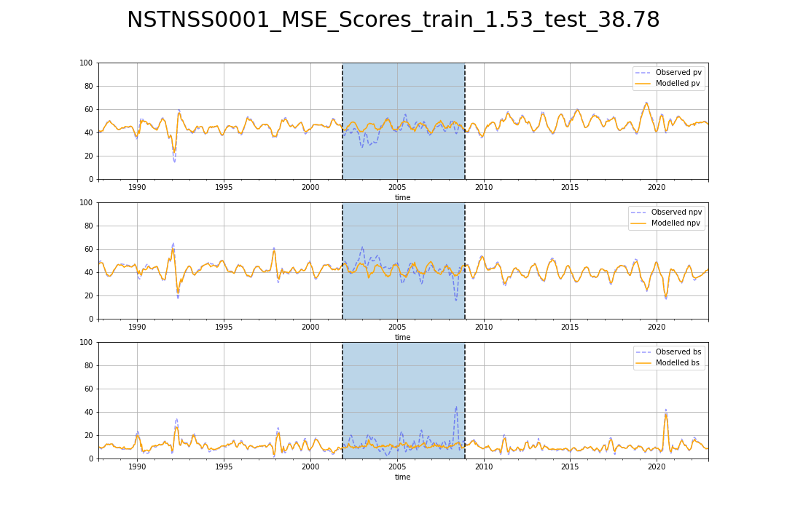

# NSTSYB0004_MSE_Scores_train_1.48_test_19.88.png

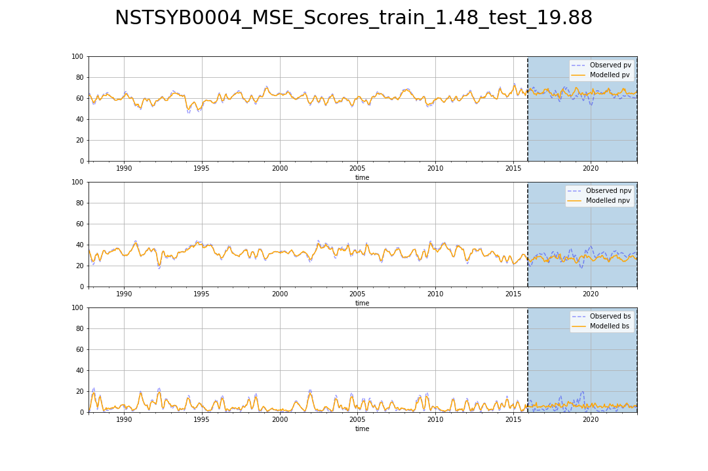

# NSTSYB0005_MSE_Scores_train_2.46_test_54.21.png

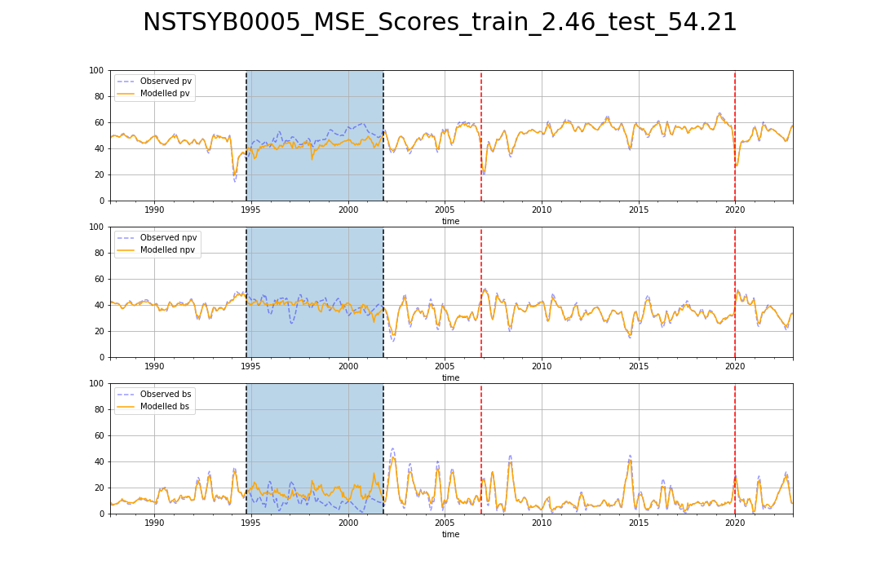

# NSTSYB0006_MSE_Scores_train_3.92_test_12.11.png

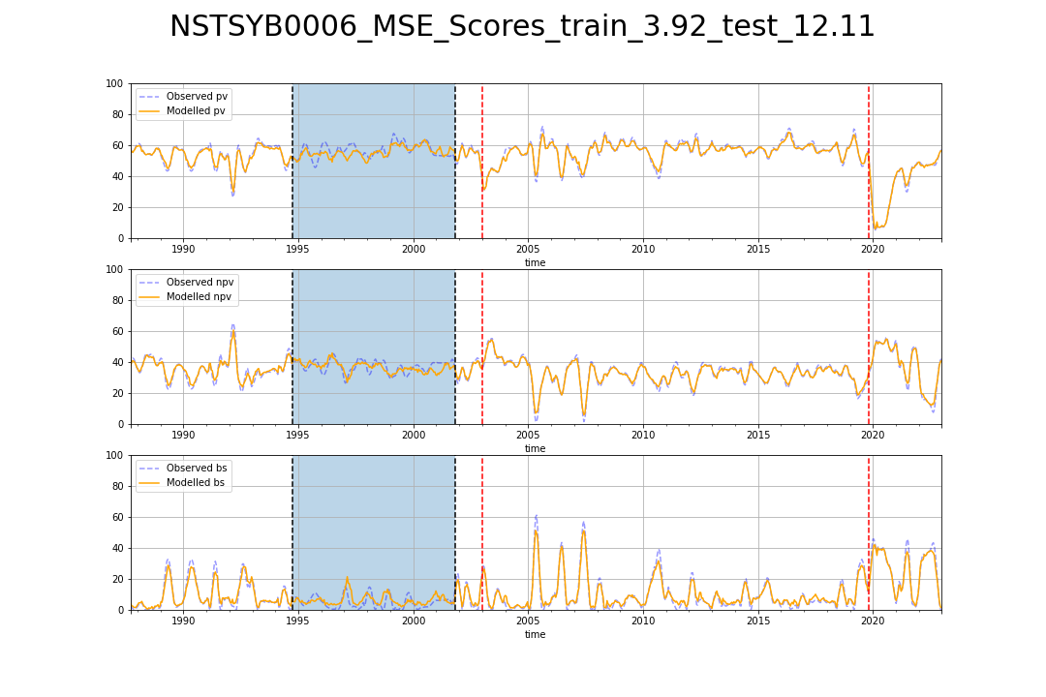

# NSTSYB0007_MSE_Scores_train_3.85_test_46.71.png

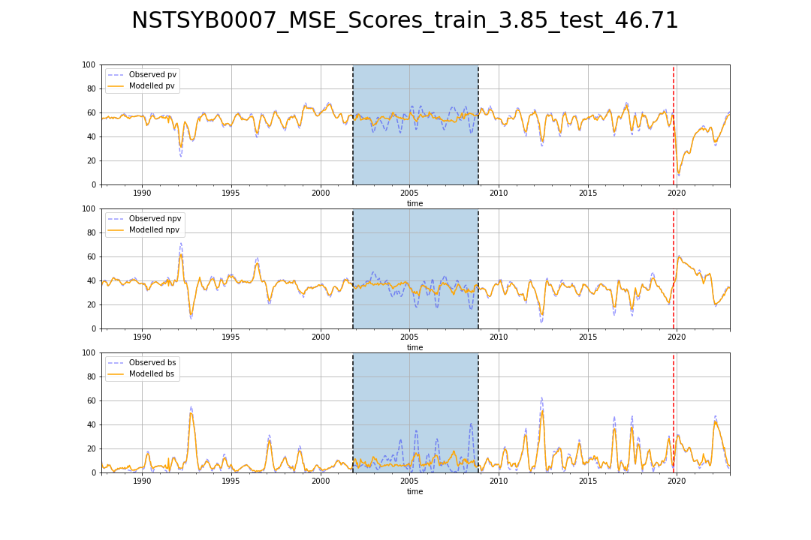

# NSTSYB0008_MSE_Scores_train_1.54_test_41.92.png

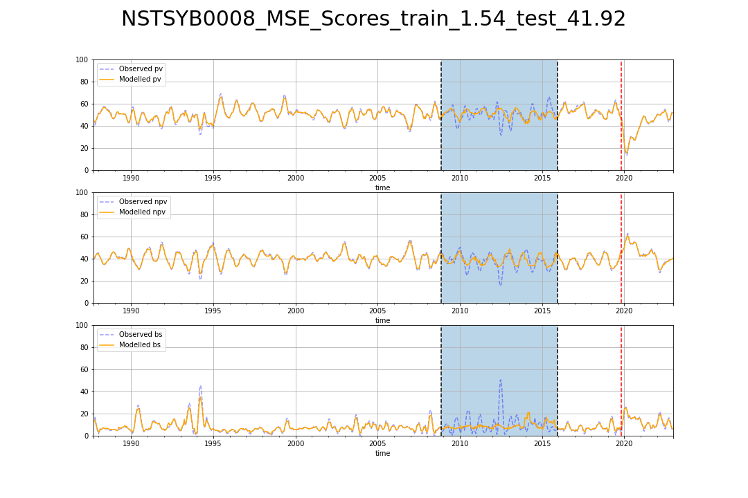

# NSTSYB0009_MSE_Scores_train_3.30_test_24.30.png

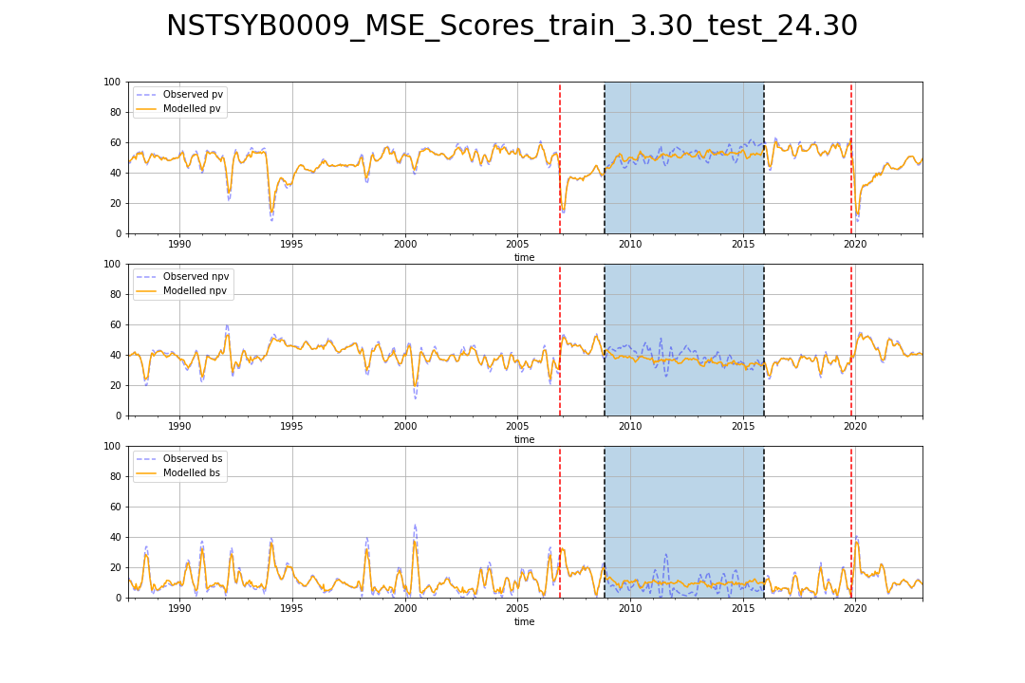

# SATFLB0015_MSE_Scores_train_2.76_test_92.46.png

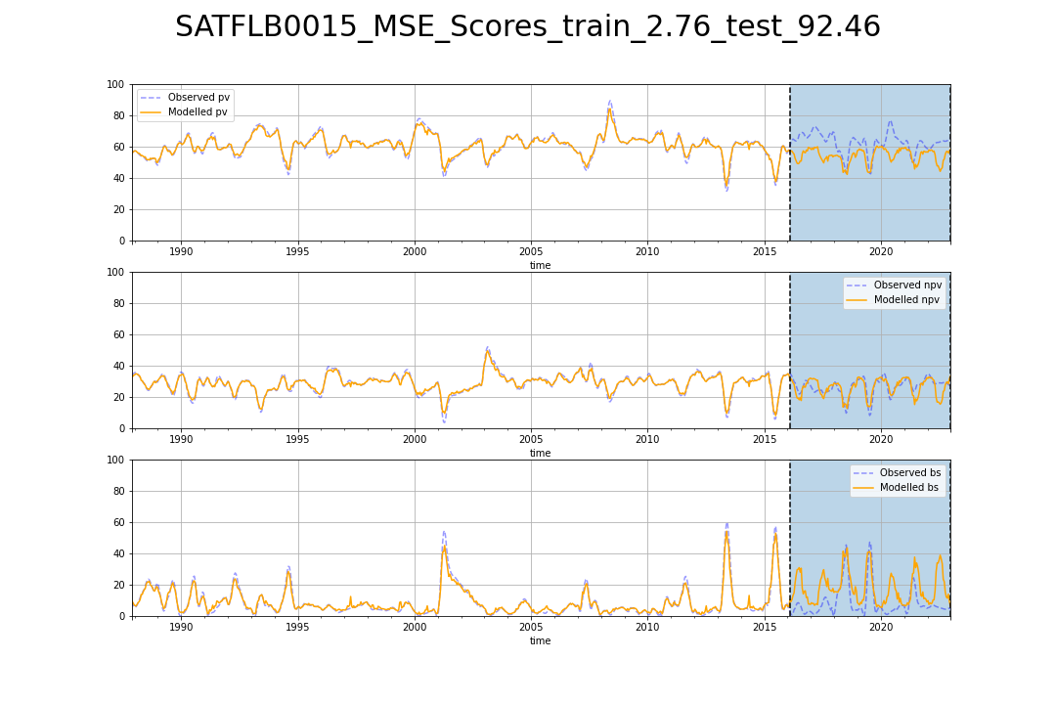

# SATFLB0026_MSE_Scores_train_1.37_test_52.52.png

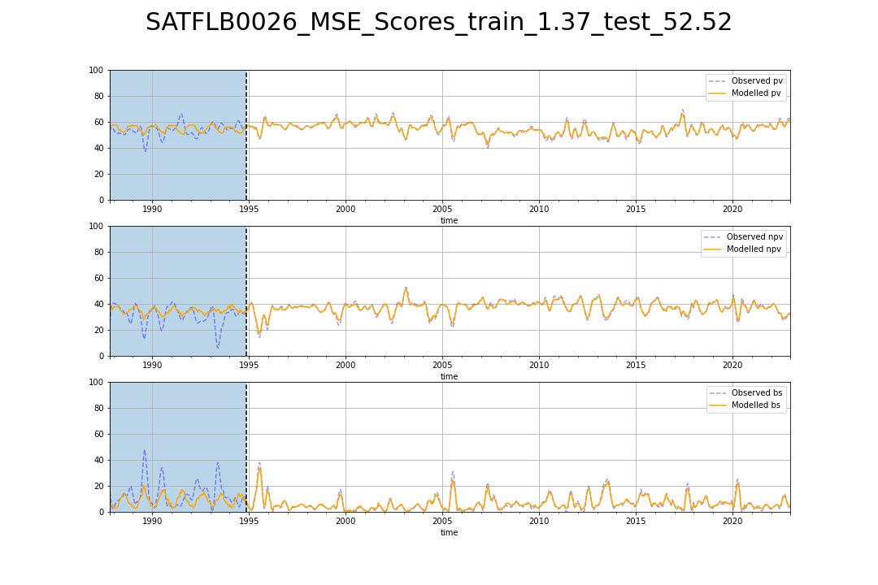

# TCABEL0001_MSE_Scores_train_5.68_test_68.36.png

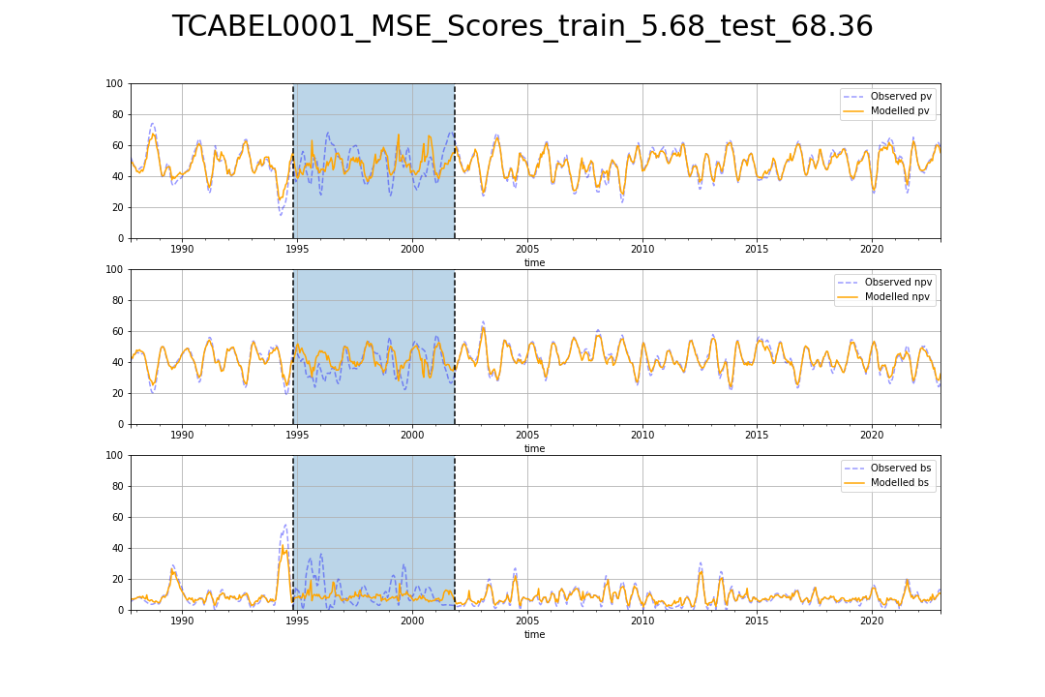

# TCABEL0002_MSE_Scores_train_7.51_test_103.21.png

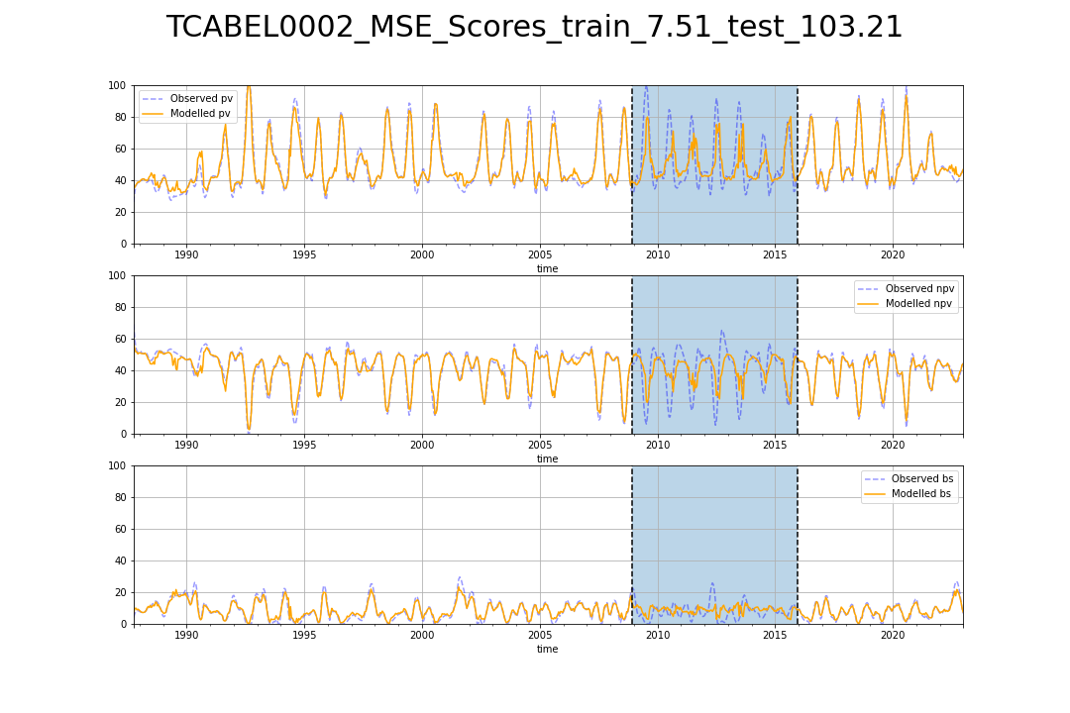

# TCABEL0003_MSE_Scores_train_7.89_test_66.77.png

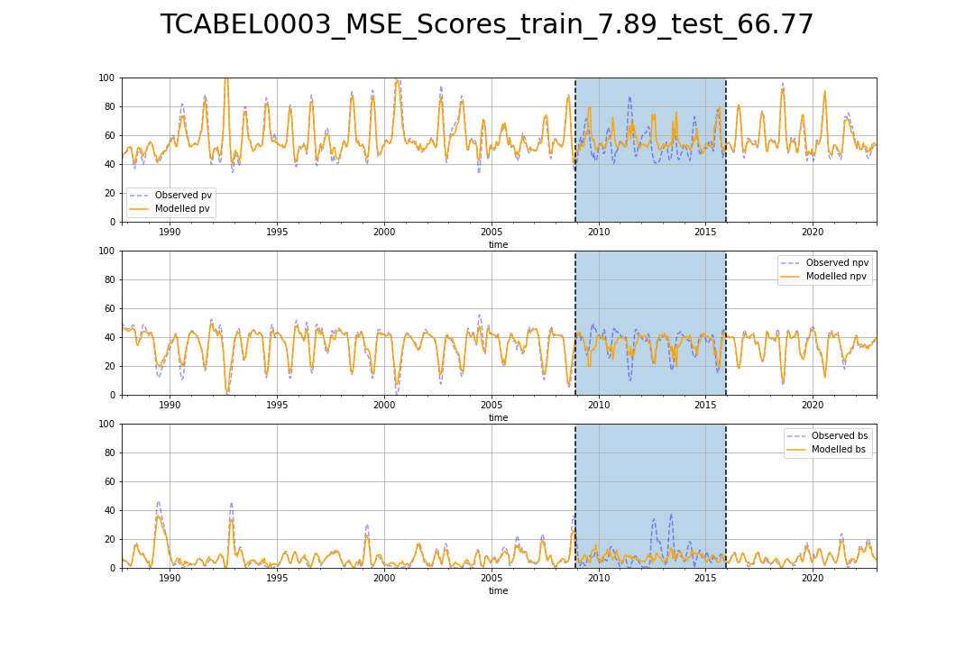

# TCATCH0001_MSE_Scores_train_6.23_test_54.62.png

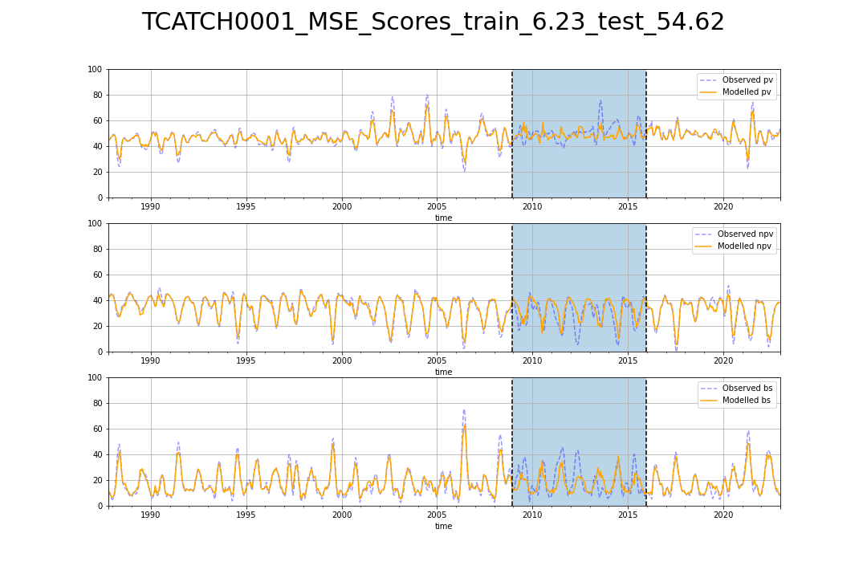

# TCATCH0002_MSE_Scores_train_4.35_test_48.98.png

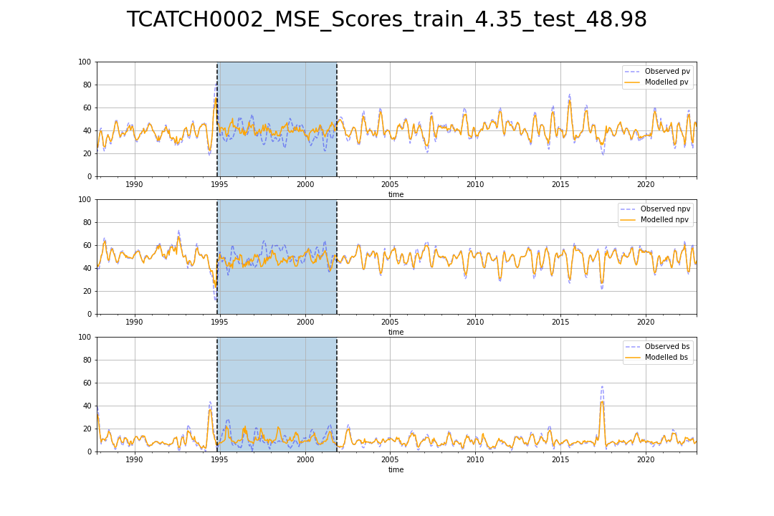

# TCATCH0003_MSE_Scores_train_3.42_test_44.83.png

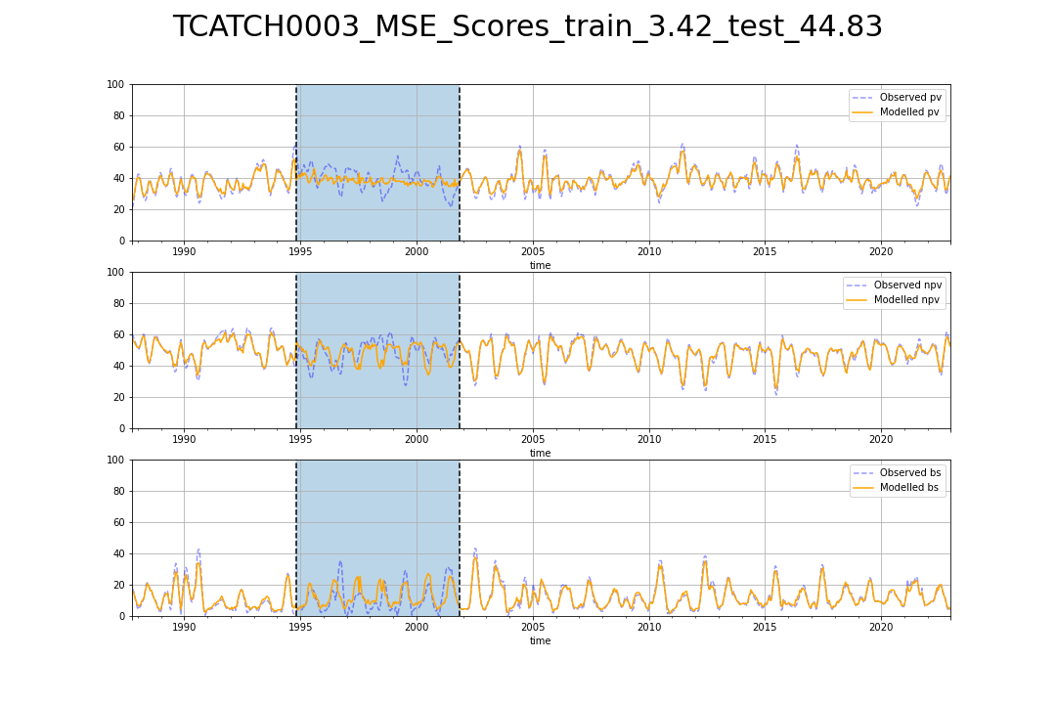

# TCATCH0004_MSE_Scores_train_4.23_test_47.22.png

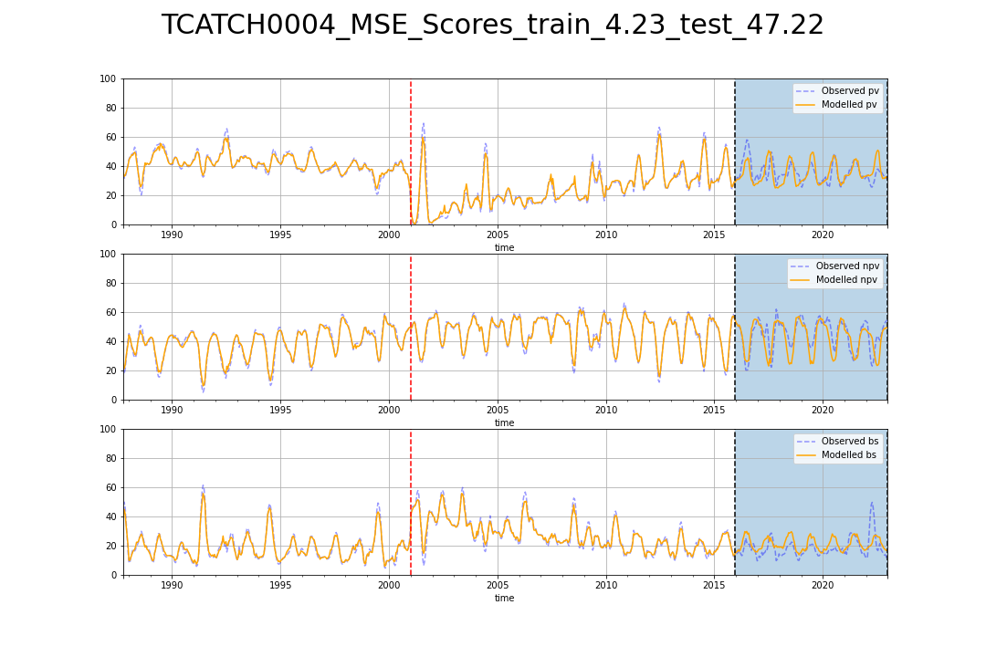

# TCATCH0005_MSE_Scores_train_5.23_test_80.90.png

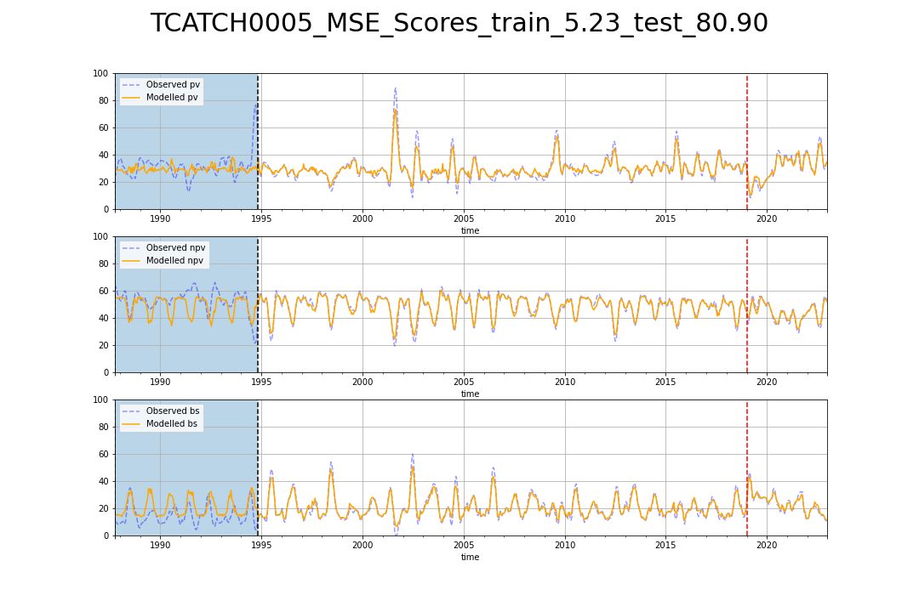

# TCATCH0006_MSE_Scores_train_5.73_test_72.78.png

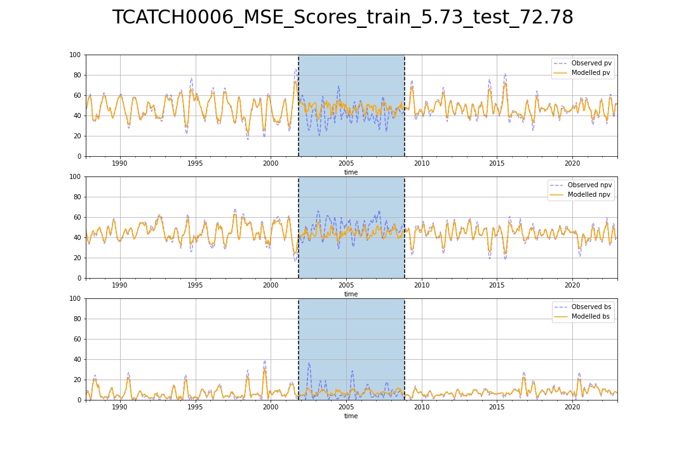

# TCATCH0007_MSE_Scores_train_5.74_test_88.32.png

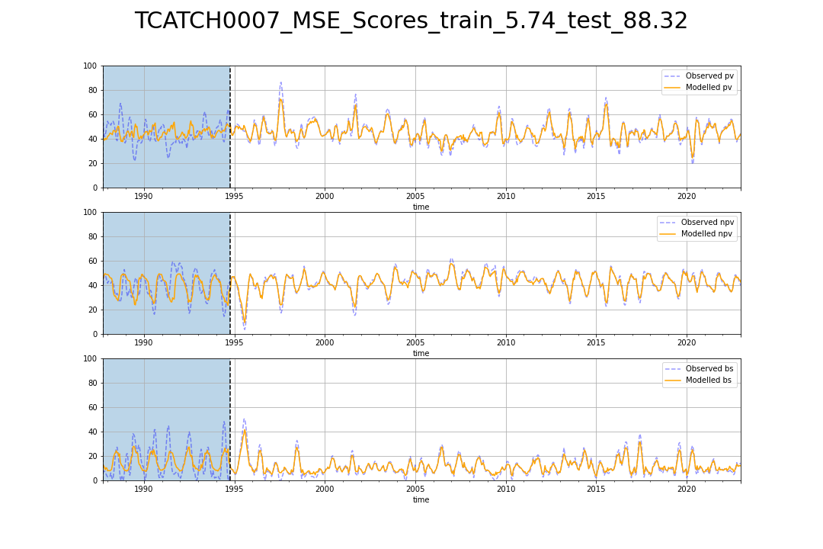

# TCATCH0008_MSE_Scores_train_5.55_test_53.85.png

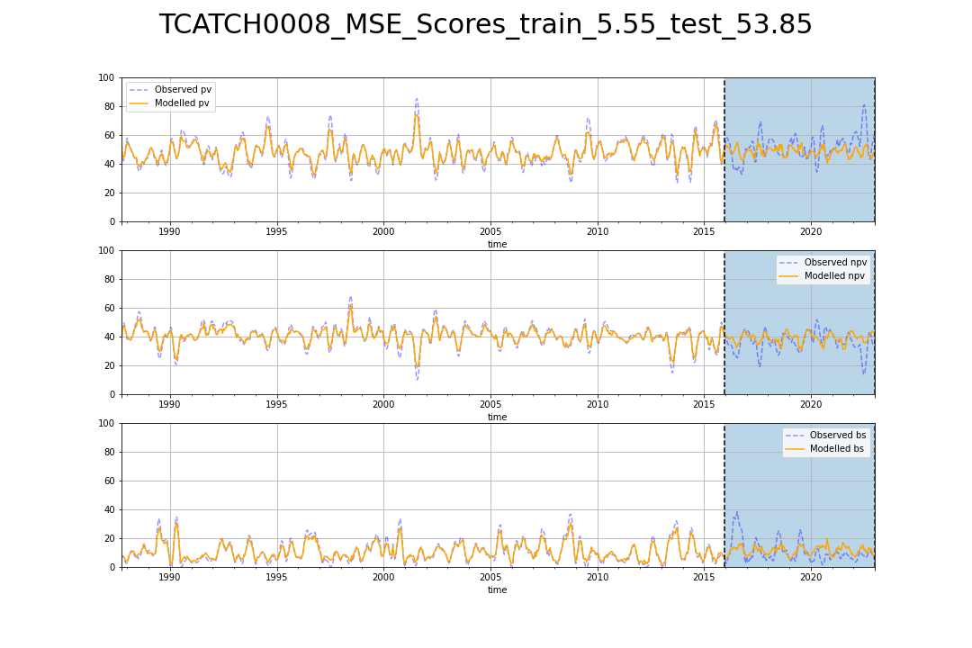

# TCATCH0009_MSE_Scores_train_9.07_test_83.72.png

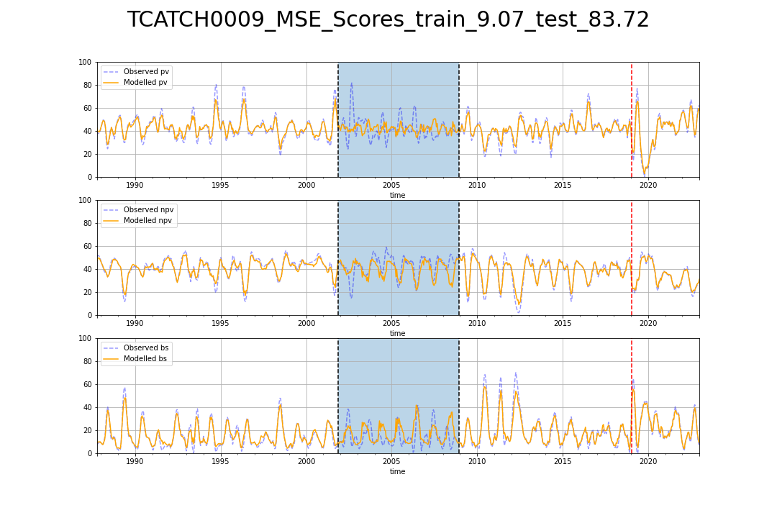

# TCATCH0010_MSE_Scores_train_4.34_test_55.44.png

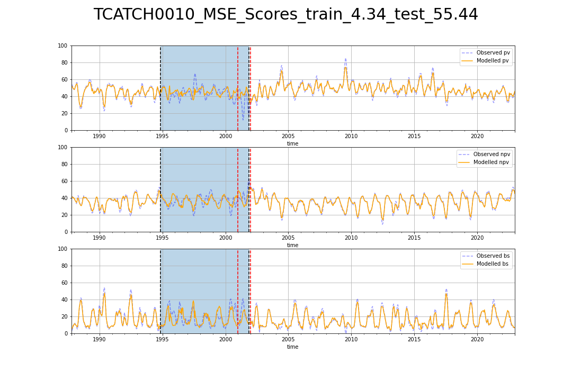

# TCATCH0011_MSE_Scores_train_4.49_test_74.45.png

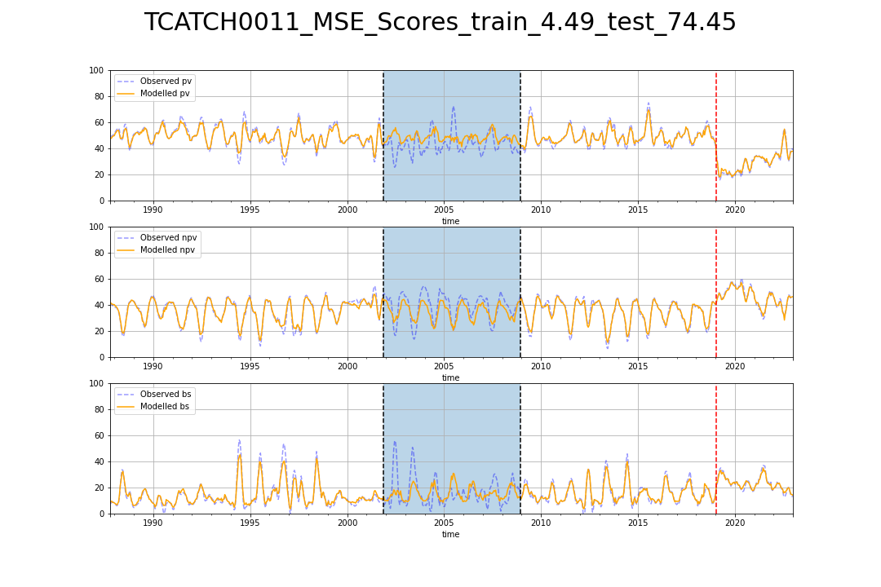

# TCATCH0012_MSE_Scores_train_4.24_test_58.34.png

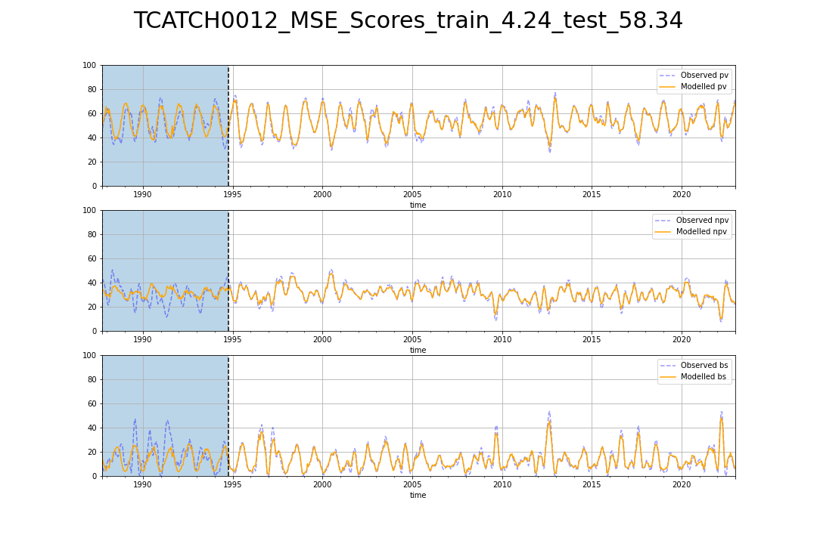

# TCATNM0001_MSE_Scores_train_4.46_test_55.70.png

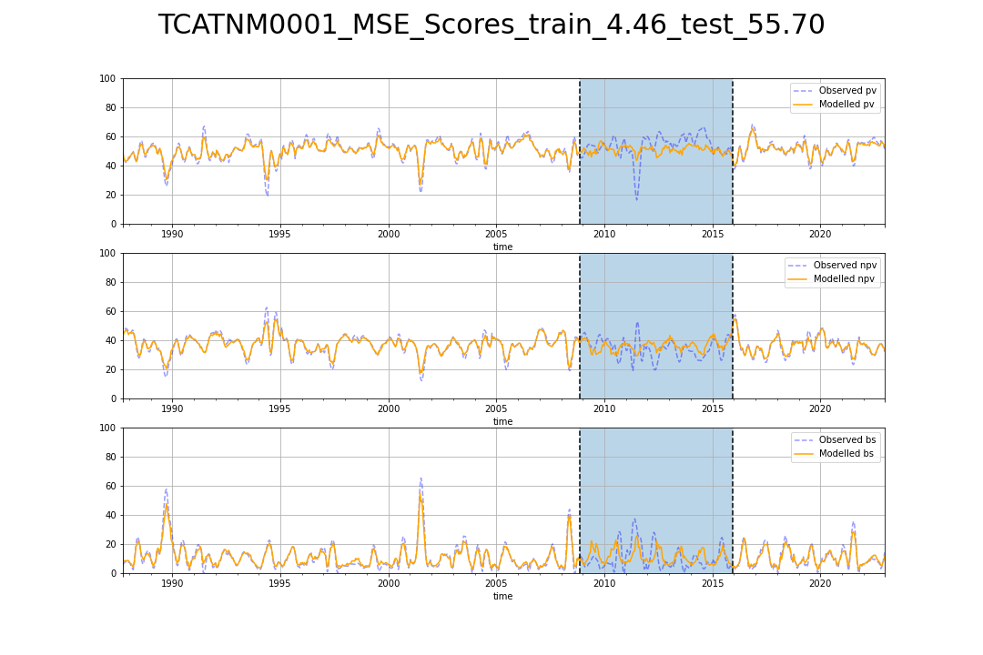

# TCATNM0002_MSE_Scores_train_5.12_test_30.56.png

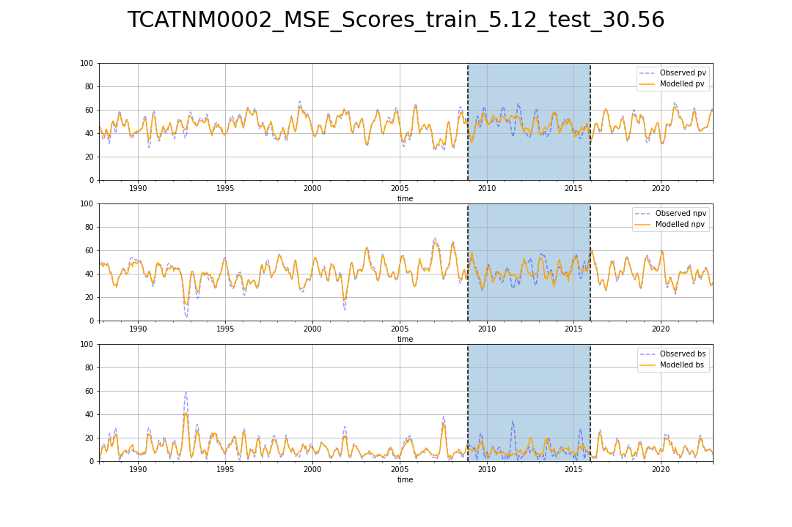

# TCATNM0003_MSE_Scores_train_3.33_test_30.81.png

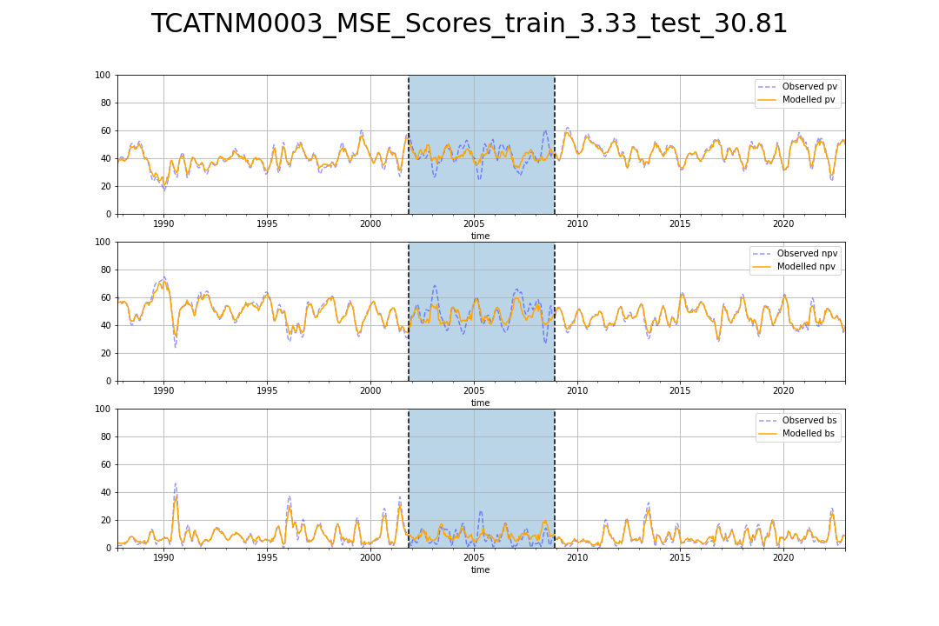

# TCATNM0004_MSE_Scores_train_2.93_test_78.35.png

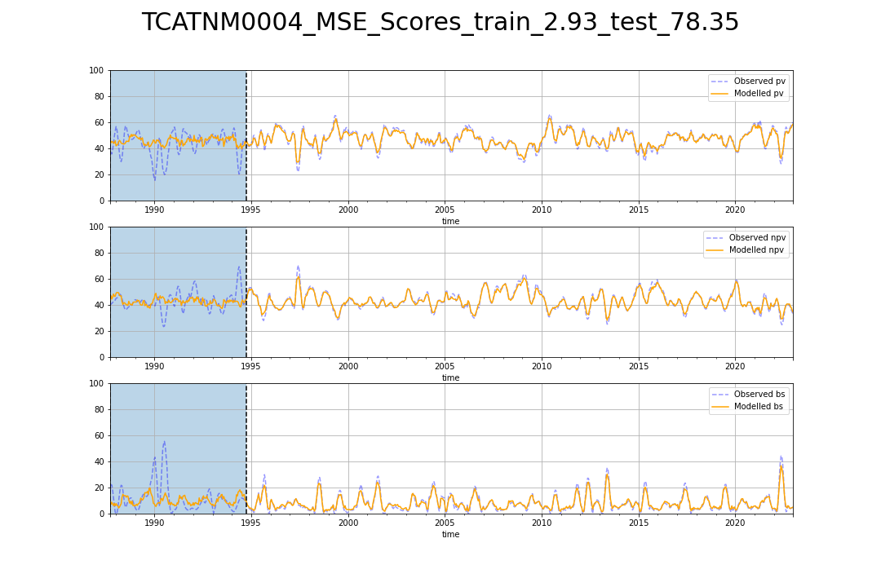

# TCATNM0005_MSE_Scores_train_2.44_test_20.55.png

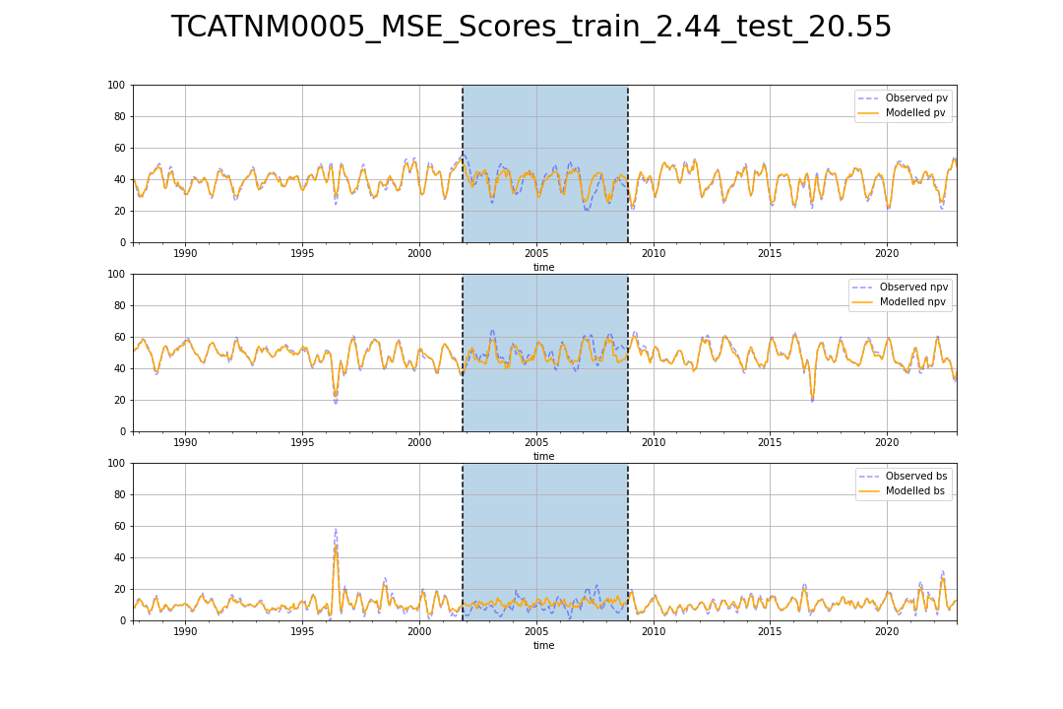

# TCATNM0006_MSE_Scores_train_5.01_test_28.55.png

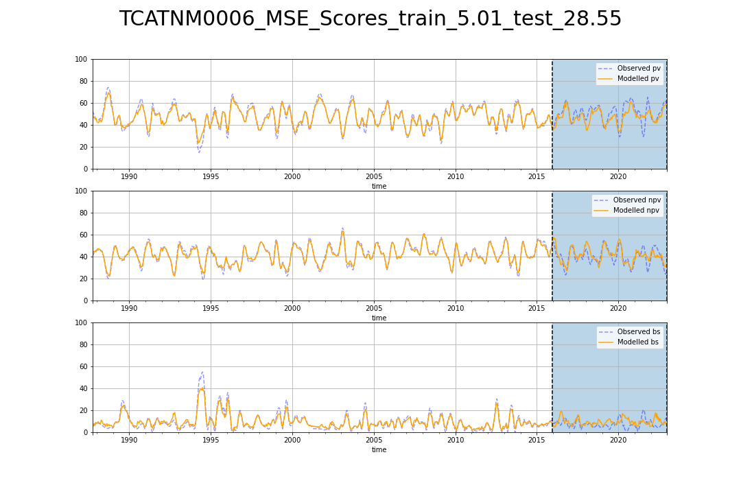

# variable_importance_Cool_Temperate.png

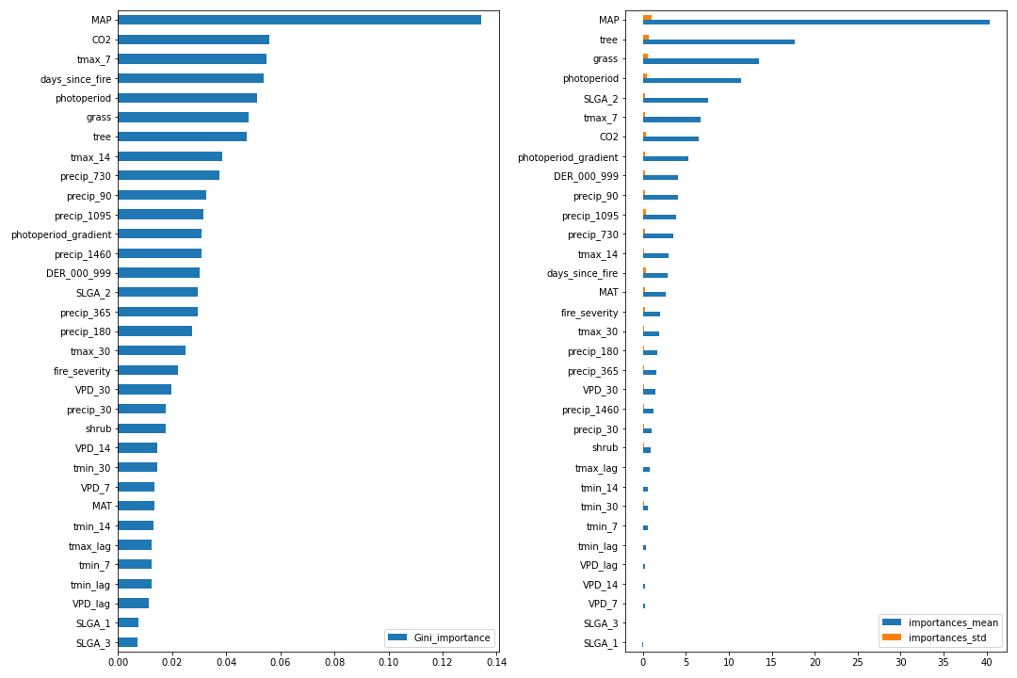

# VCAAUA0001_MSE_Scores_train_4.18_test_46.54.png

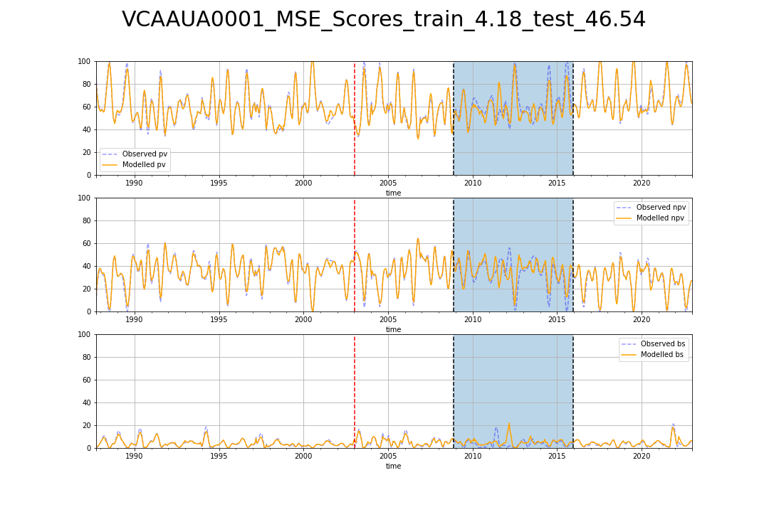

# VCAAUA0002_MSE_Scores_train_4.28_test_18.56.png

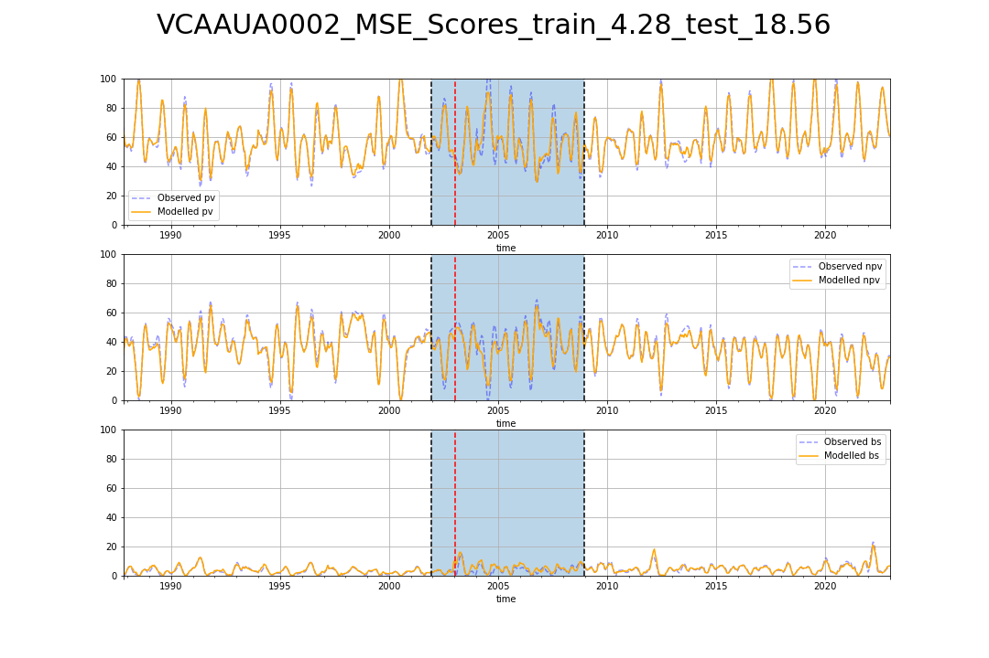

# VCAAUA0003_MSE_Scores_train_5.04_test_37.35.png

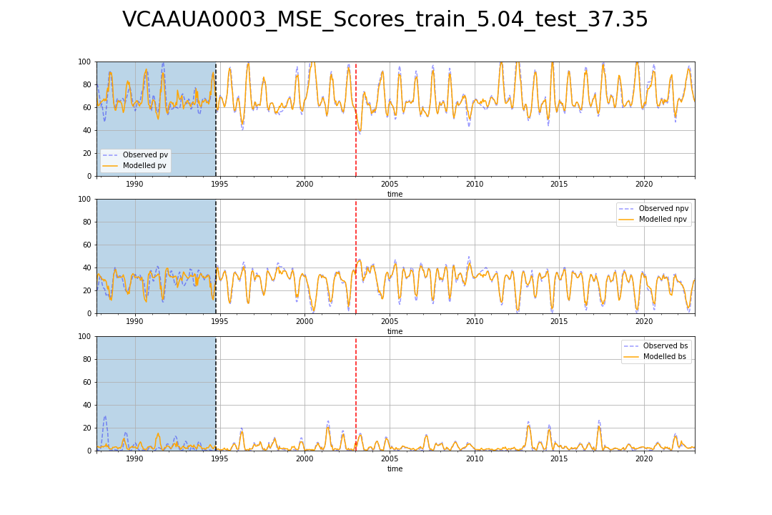

# VCAAUA0005_MSE_Scores_train_4.31_test_60.31.png

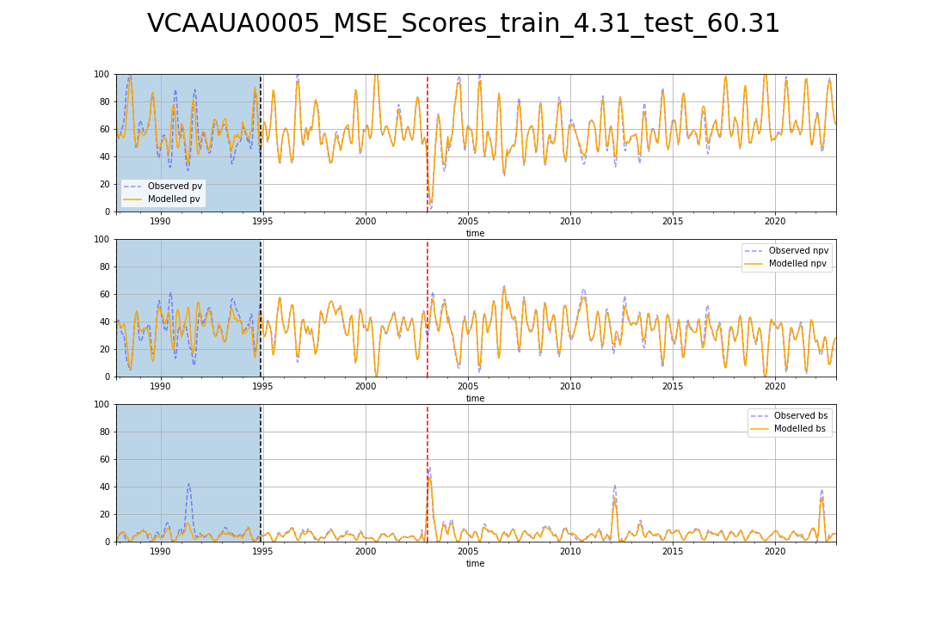

# VCAAUA0007_MSE_Scores_train_4.68_test_46.00.png

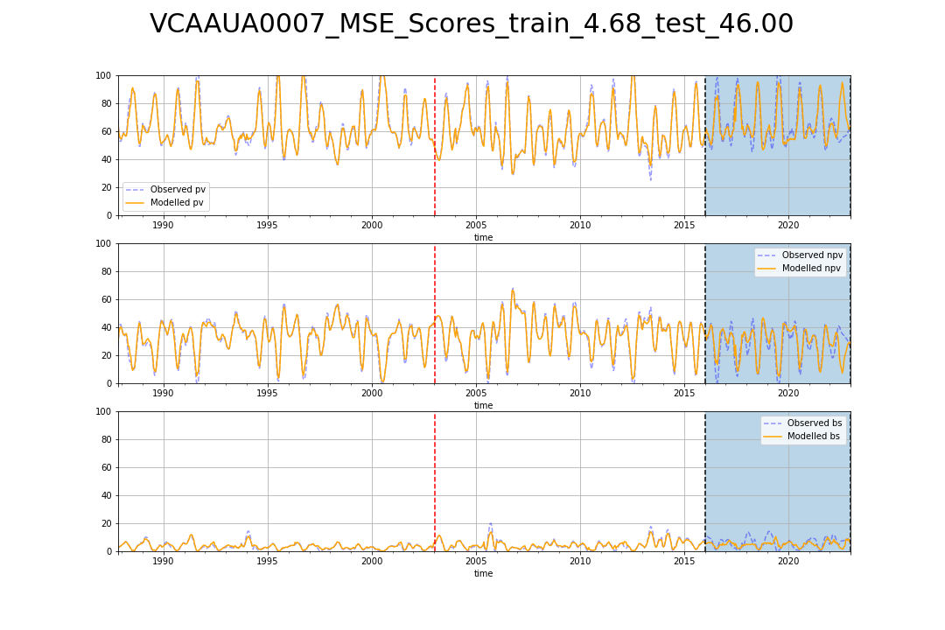

# VCAAUA0008_MSE_Scores_train_4.01_test_23.08.png

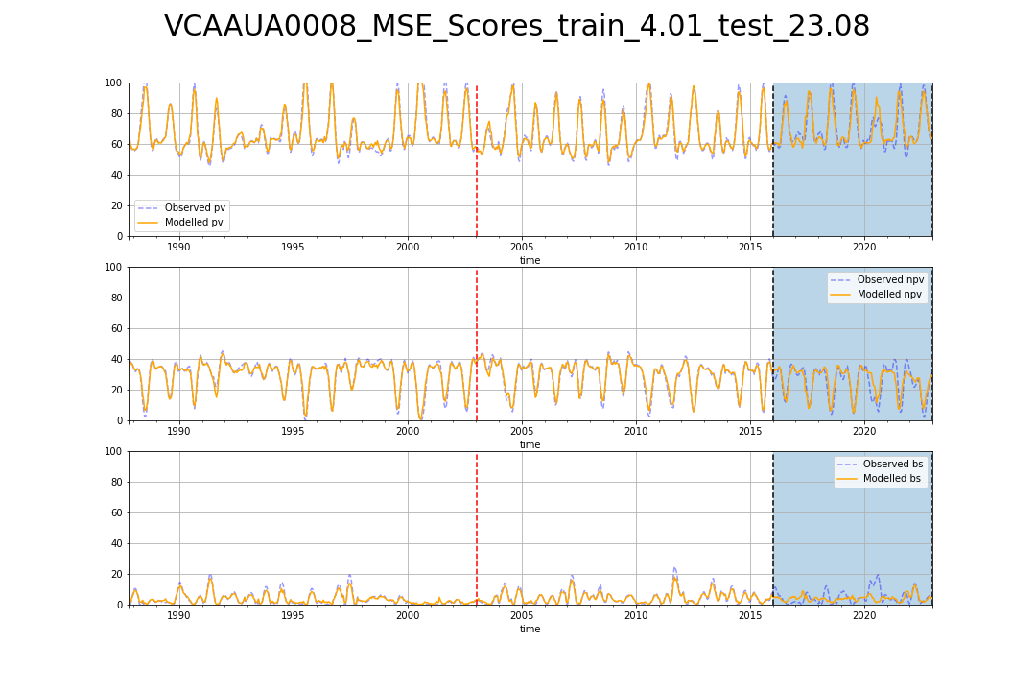

# VCAAUA0009_MSE_Scores_train_4.74_test_30.76.png

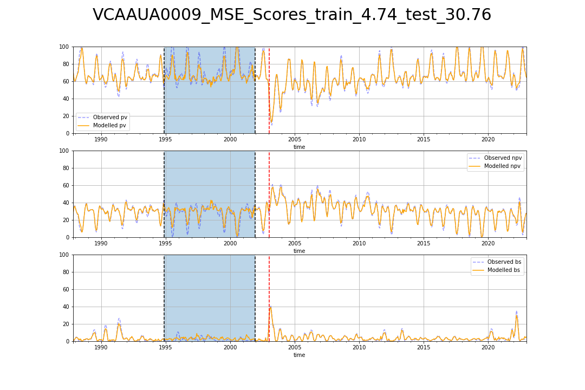

# VCAAUA0010_MSE_Scores_train_6.03_test_61.57.png

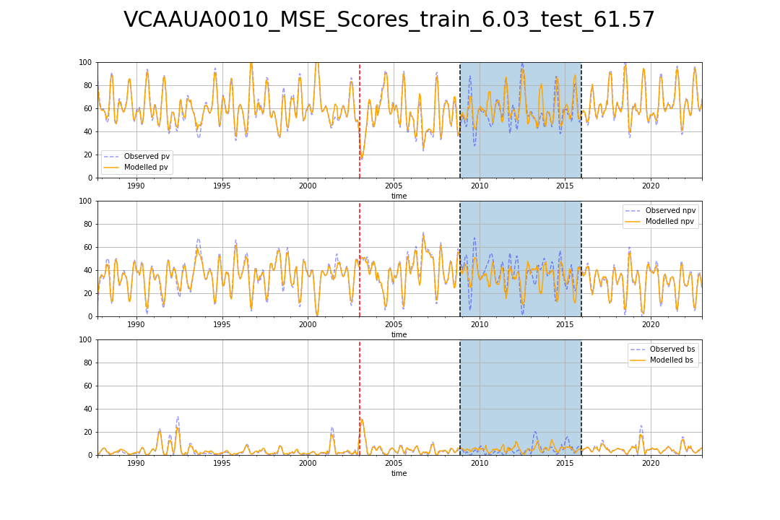

# VCAAUA0011_MSE_Scores_train_6.86_test_70.79.png

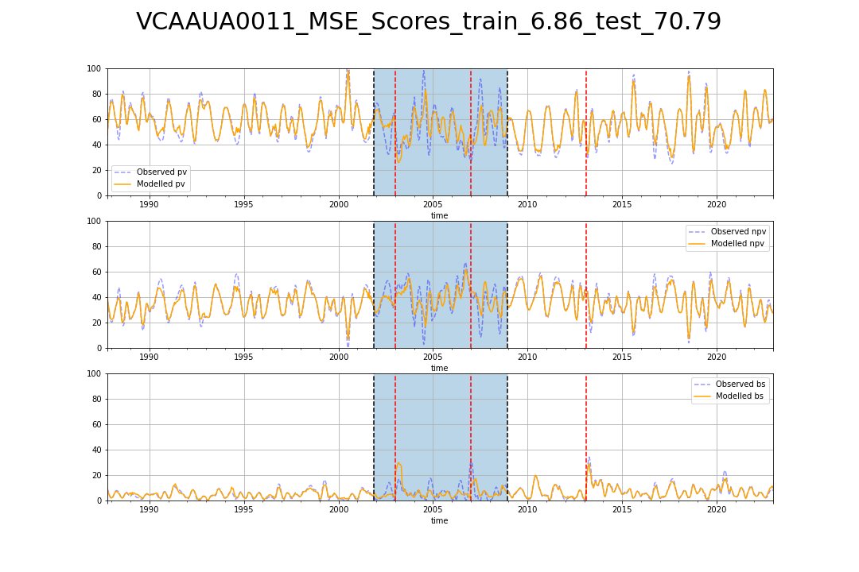

# VCAAUA0012_MSE_Scores_train_7.40_test_44.71.png

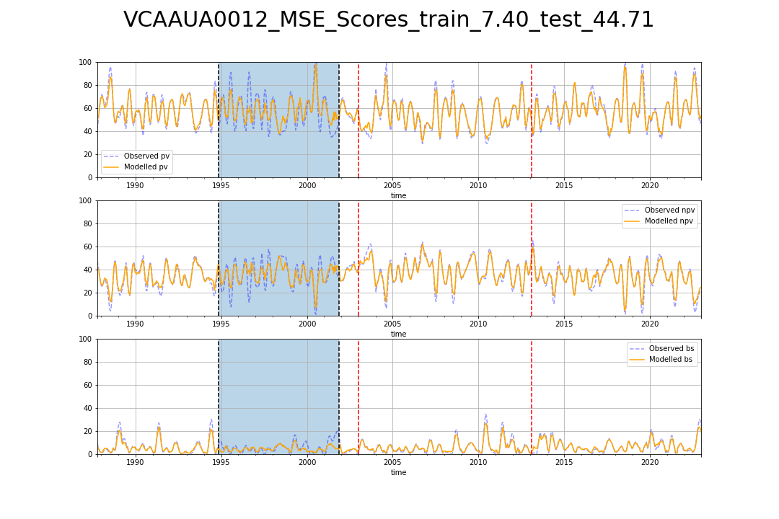

# VCAAUA0013_MSE_Scores_train_5.30_test_23.43.png

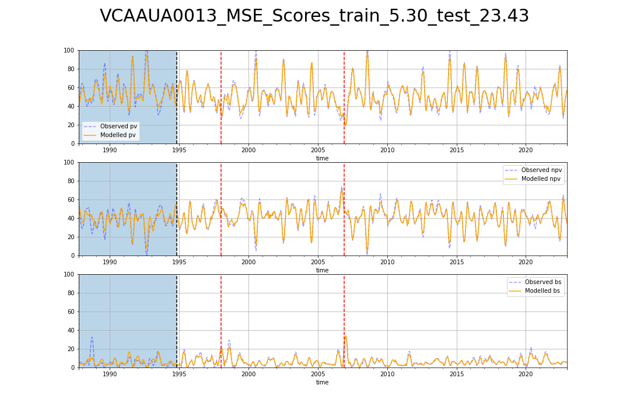

# VCAAUA0014_MSE_Scores_train_3.71_test_54.25.png

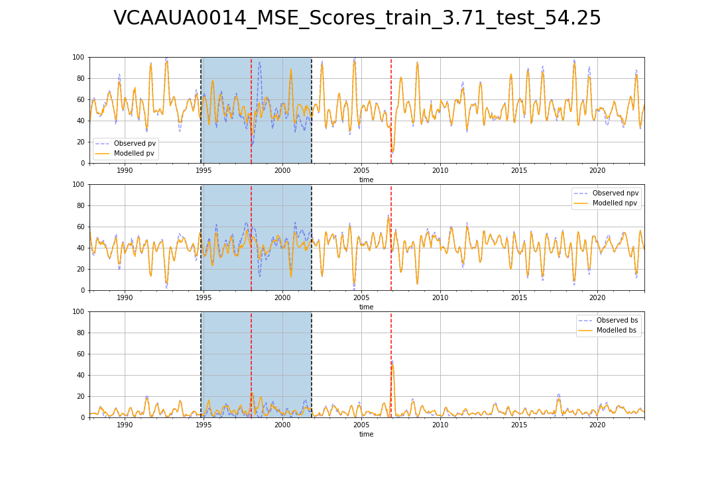

# VCAAUA0015_MSE_Scores_train_3.96_test_21.79.png

